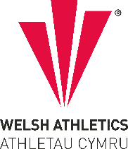

West Wales Regional Athletics Council

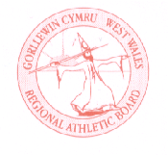
Minutes – West Wales Regional Athletics Council
Wednesday 11th December 2024
Microsoft Teams Meeting
__________________________________________________________________________________________
Present: Rob Campion Chairman
Nathan Jones Secretary
Les Cuthbert Treasurer
Andrew Jenkins Afan Nedd Tawe Schools Athletic Association
Lisa Campion Track & Field Committee Representative
Steve Hames Welfare Officer
Nigel Jones Officials Committee Representative (Endurance)
Owain Schiavone FMR Committee Representative
Gareth Harries Officials Secretary
Jennifer Boyce Pembrokeshire Harriers
Aled Jones-Davies TROTS

_______________________________________________________________________________________

Apologies: Kevin Tobin
_______________________________________________________________________________________

Actions from Previous Meeting
Starter Kit - currently stored in Neath. Purchasing proper case that it doesn’t get damaged, Ongoing
5K Championships – Ongoing
West Wales 10K Championships at St Clears 10K – Region contributing towards chip timing
_______________________________________________________________________________________

- Discussion

- Welsh Inter-Regional Cross Country Championships - Newtown
At Newtown on Saturday 16th November on the same day as the Welsh Inter-Schools and Colleges Championships. West Wales teams did well with several individual and team medals won. Again this year, it clashed with the British & Irish Masters Cross Country International, which affected this age group in Newtown. Athletes have expressed that the event clash should be avoided in the future.

- West Wales indoor update and regional events - Cardiff
200m, 300m and 400m were held two weeks ago. Unfortunately, numbers who attended were not great especially in the boys’ categories.
Next - Sunday 5th January – 800m and 1500m incorporated into day 2 of the junior open.
West Wales Indoor Championships in Swansea: Entries have opened last weekend. Saturday 11th January (Jumps) and Saturday 15th February (Track/Shot). Field judging course on a Tuesday and Thursday evening in the week leading up to 11th. Date being arranged for race director course in the West and race starter course. Officials being contacted about these.

- UK Inter-Counties Cross Country Championships - March
West Wales will again be fielding teams in the UK Inter Counties Cross Country Championships which are incorporated into the 5th and final round of the British Athletics Cross Challenge Series at Nottingham.
This year’s selection criteria:
- For the U20 and Senior teams, there will be no selection criteria, instead expressions of interest of representing West Wales should be emailed to the lead team manager no later than Tuesday 7th January.
- For the U13, U15 & U17 teams, the first six West Wales eligible athletes to finish at Newtown will receive automatic selection. U13 U15 & U17 athletes who finished outside of the top six places that wish to be considered for selection to fill the remaining 2 team places should email the team leader no later than Tuesday 7th January.

- Welsh Junior League 2025 – plans for the West Wales region
Number of suggestions around the league next summer. West Wales would like to continue with the same set up as in previous years. Running a full programme for U11, U13 and U15 age groups. Three dates provisionally could be 18th May, 21st/22nd June and 2nd/3rd August. This matter needs to be taken to the next meeting to plan properly.

- Gerry Batty Award
West Wales Regional Athletics Council Gerry Batty Memorial U17/U20 Junior Athlete of the Year Award, over the period 1st October 2023 to 1st October 2024 inclusive. Four athletes shortlisted to be analysed further before next meeting.

- Welsh Inter-Regional Track & Field Championships
West Wales to host the 2025 edition of the Inter Regional Championships in the region. 12th July is the date set, booking Carmarthen. More to follow.

__________________________________________________________________________________________
- Information – Reports

- General Council
Welsh Athletics Chief Executive attended to update, including stripe accounts. Webinars in January on the new age group changes.

- Track and Field Committees
Last meeting was cancelled.

- Officials Committee and Secretary
New officials courses being arranged. New email sent out for availability at West Wales Championships and officials courses.

- Road Running/Cross Country Committee
Fixtures
Welsh Cross Country Championships now in Pembrey (different course to usual) on Saturday 25th January 2025.
Also the various other dates as noted
Inter Schools and Inter Regional X/C
Quite a lot of debate as to whether they are separated and/or if the Inter Schools becomes a relay. Discussions ongoing WA/WS.

- FMR Committee
Red Kite Challenge update given regarding 2025 fixture. British & Irish Mountain Running Championships in Devil’s Bridge (not confirmed) 13th September. Trial in Eryri possibly in July, current planning.

- Welfare Officer
Nothing to update.
_______________________________________________________________________________________
- Financial Report (correct on Tuesday 10th December)
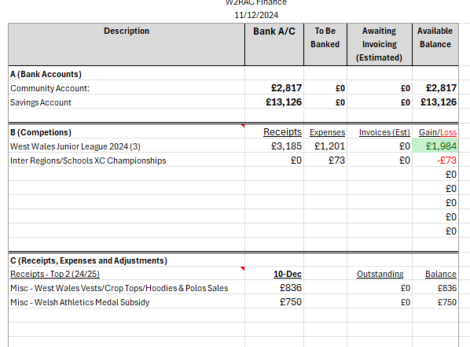
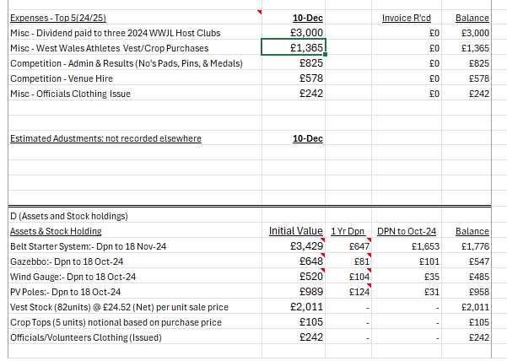
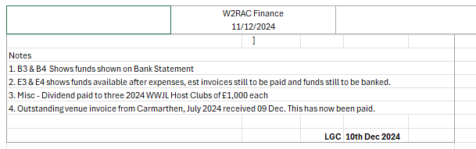

- AOB

None

- Date of Next Meeting Friday 7th February at 6:30pm – Canolfan Gwili, Hendy (in person/online)

